**IDEATION PHASE**

**Define the Problem Statements**

|  |  |
| --- | --- |
| **Team ID** | **PNT2022TMID13652** |
| **Project Name** | **Smart Waste Management System for Metropolitan Cities** |
| **Maximum Marks** | **2 Marks** |

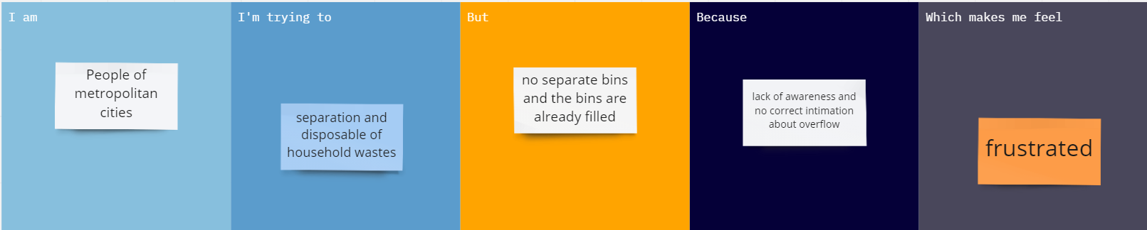

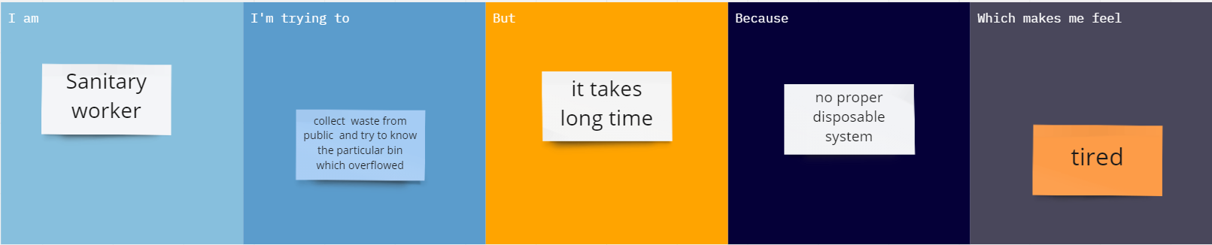

|  |  |  |  |  |  |
| --- | --- | --- | --- | --- | --- |
| **PROBLEM STATEMENT** | **I AM (Customer)** | **I’m TRYING TO** | **BUT** | **BECAUSE** | **WHICH MAKES ME FEEL** |
| PS -1 | People of metropolitan cities | Dispose my bio-degradable and non-bio-degradable waste in the garbage bins near my house | There is no separate bins for disposing both the types of waste and sometimes the dustbins were overflowed | Lack of awareness and also the municipal workers didn’t aware about the overflow of waste in the dustbin. | frustrated. |
| PS -2 | Sanitary worker | Collect waste from public and try to know where the bins are overflowed | I can’t able to find the overflowed bin among all the bins at everytime. | There is no proper system to intimate the overflowed dustbins. | Tired |